ChairPersons Report

John Kamau

11/07/2019

# Q_6.And are you the chairperson of the {0} VSLA?

|  |  |  |
| --- | --- | --- |
| Position | Mali | Uganda |
| Yes | 151 | 138 |
| No, chairperson isn’t available, so you have me (please specify position | 1 | 5 |
| Respondents | 152 | 143 |

# Q_8.Have you been with the group since the start?

|  |  |  |
| --- | --- | --- |
| Position | Mali | Uganda |
| Yes | 144 | 96 |
| No | 8 | 47 |
| Respondents | 152 | 143 |

# Q_11.Have you been the chairperson continuously since that time?

|  |  |  |
| --- | --- | --- |
| Duration | Mali | Uganda |
| Yes, continuously | 127 | 92 |
| No, for a while someone else was chairperson | 24 | 50 |
| Other (specify) | 1 | 1 |
| Respondents | 152 | 143 |

# Q12. How did you become chairperson?

|  |  |  |
| --- | --- | --- |
| Method | Mali | Uganda |
| I was elected with voting | 27 | 91 |
| We talked about it and we agreed I should be chairperson | 115 | 39 |
| I was appointed (e.g. by village leader, group trainer…) | 8 | 11 |
| Other (specify) | NA | 2 |
| I don’t remember | 2 | NA |
| Respondents | 152 | 143 |

# Q13. As chairperson, what are your duties? (Multiple Selection)

|  |  |  |
| --- | --- | --- |
| variable | Mali | Uganda |
| Open or close the meetings | 141 | 104 |
| Oversee the meetings | 96 | 119 |
| Help the members stay disciplined | 87 | 93 |
| Decide the penalties that members pay | 81 | 41 |
| Resolve conflicts around repayment | 76 | 90 |
| Resolve other conflicts between members | 79 | 79 |
| Represent the group in the community | 73 | 76 |
| Train the group committee | 40 | 30 |
| Make sure the bookkeeping is correct | 31 | 43 |
| Train new members | 21 | 26 |
| It is an honorary or ceremonial post with no duties | 6 | 2 |
| Other( please specify) | 2 | 7 |
| Respondents | 152 | 143 |

# Q_14.Are there other members who could fulfill the post of chairperson, if you were not around?

|  |  |  |
| --- | --- | --- |
| Chairpersons_Replacement | Mali | Uganda |
| Yes, many | 110 | 28 |
| Yes, a few | 35 | 91 |
| I am training my replacement now | 1 | 7 |
| No, I am necessary | 5 | 3 |
| I don’t know | 1 | 14 |
| Respondents | 152 | 143 |

# Q21 Did the group already exist under some other form before it was trained as a VSLA?

|  |  |  |
| --- | --- | --- |
| Form | Mali | Uganda |
| Yes | 17 | 42 |
| No | 135 | 101 |
| Respondents | 152 | 143 |

# Q22 What happened to the group membership after you received training?

|  |  |  |
| --- | --- | --- |
| variable | Mali | Uganda |
| Some members left | 36 | 82 |
| Membership stayed the same | 32 | 18 |
| New members joined | 88 | 96 |
| I don’t know | 8 | 10 |
| Does not want to answer | 1 | 4 |
| Respondents | 154 | 124 |

# Q_25.What organization did the trainer {0} work with?

|  |  |  |
| --- | --- | --- |
| Organization | Mali | Uganda |
| Approcel | NA | 22 |
| Bantwana Mothers to Mothers | NA | 1 |
| c’est un membre d’un autre groupe | 1 | NA |
| caeb | 16 | NA |
| care | NA | 19 |
| chômeur danes le village | 1 | NA |
| community vision | NA | 1 |
| community vision. | NA | 4 |
| from church | NA | 2 |
| from diocese | NA | 4 |
| from the diocese | NA | 1 |
| i can’t remember | NA | 1 |
| IDFA | NA | 9 |
| IDFA (Iganga District Farmers association | NA | 1 |
| IDFA(Iganga District Farmers Association | NA | 1 |
| Iganga farmer’s association | NA | 1 |
| Iganga farmers association | NA | 8 |
| je ne sais pas | 1 | NA |
| JED | 12 | NA |
| jeunesse et développement | 3 | NA |
| OXFAM | 13 | NA |
| PAM | 3 | NA |
| Recode | NA | 1 |
| RECODE | NA | 7 |
| rer | NA | 1 |
| RUCODE | NA | 1 |
| RUDIFA | NA | 2 |
| SABATI | 1 | NA |
| Sepsel | NA | 11 |
| sepspel | NA | 1 |
| Sepspel | NA | 2 |
| tékéréne | 1 | NA |
| UWESO | NA | 1 |
| village agent | NA | 1 |
| with church | NA | 1 |
| Respondents | 52 | 104 |

# Q_26.Did you ever support {0} with small gifts or money? (Multiple Selection)

|  |  |  |
| --- | --- | --- |
| variable | Mali | Uganda |
| Yes, regular payments of money for training | 0 | 23 |
| yes. irregular payment of money | 0 | 24 |
| yes. frequent gifts of food, airtime, clothes, etc. | 0 | 4 |
| Yes, irregular gifts of food, airtime, clothes,etc. | 0 | 8 |
| Yes, money at share-out time | 1 | 47 |
| Other: | 27 | 4 |
| No | 127 | 46 |
| Don’t know | 0 | 9 |
| Respondents | 152 | 143 |

# Q27. Thinking about the training you received, which of the following best describes it?

|  |  |  |
| --- | --- | --- |
| Training | Mali | Uganda |
| It was very good and we are independent | 58 | 65 |
| It was good but we still appreciate help | 72 | 58 |
| It was good but there are things we don’t know so we need help | 19 | 9 |
| It was lacking some things (describe) | 1 | NA |
| I don’t know | 2 | 9 |
| Other (specify) | NA | 2 |
| Respondents | 152 | 143 |

# Q28. Does the group still receive visits from [NGO name]?

|  |  |  |
| --- | --- | --- |
| Visits | Mali | Uganda |
| Yes | 9 | 24 |
| No | 134 | 118 |
| I don’t know | 9 | 1 |
| Respondents | 152 | 143 |

# Q30.Have you or any members of your group ever trained any other group to help them form their own VSLA?

|  |  |  |
| --- | --- | --- |
| Trainings | Mali | Uganda |
| Yes | 12 | 37 |
| No | 140 | 106 |
| Respondents | 152 | 143 |

# Q34. In the past, has your group ever gotten so big that some members left to start a new group?

|  |  |  |
| --- | --- | --- |
| Size | Mali | Uganda |
| Yes | 11 | 16 |
| No | 141 | 115 |
| I don’t know | NA | 12 |
| Respondents | 152 | 143 |

# Q38. Do you think you yourself could train other people to form a new VSLA?

|  |  |  |
| --- | --- | --- |
| Trainings | Mali | Uganda |
| Yes | 51 | 106 |
| No | 101 | 37 |
| Respondents | 152 | 143 |

# Q41 Do you ever share new ideas with other groups?

|  |  |  |
| --- | --- | --- |
| Ideas | Mali | Uganda |
| Yes | 40 | 39 |
| No | 112 | 104 |
| Respondents | 152 | 143 |

# Q43. Have other groups ever shared new ideas with your group?

|  |  |  |
| --- | --- | --- |
| Ideas | Mali | Uganda |
| Yes | 38 | 17 |
| No | 114 | 126 |
| Respondents | 152 | 143 |

# Q45 FUNCTION: How does your group operate?

|  |  |  |
| --- | --- | --- |
| Operations | Mali | Uganda |
| The group retains savings from meeting to meeting with prime purpose to lend out and give savings back (DISTRIBUTING ASCA) | 133 | 123 |
| The group retains savings indefinitely and lends to members for investment, household expenses, or to pay for members’ emergencies such as funerals (NON DISTRIBUTING ASCA) | 18 | 4 |
| The group collects savings at every meeting, and gives all the collected funds to one member in turn, and the group retains no money from meeting to meeting (ROSCA) | NA | 2 |
| Other (specify) | 1 | 14 |
| Respondents | 152 | 143 |

# Q46. PURPOSE: What is the primary reason the group came together?

|  |  |  |
| --- | --- | --- |
| purpose | Mali | Uganda |
| Non-specific financial services | 8 | 83 |
| Farmers group | 1 | 9 |
| Social group | 88 | 24 |
| Funeral society | NA | 2 |
| Women’s group | 26 | 3 |
| Business group | NA | 10 |
| Other(specify) | 29 | 12 |
| Respondents | 152 | 143 |

# Q47 How does the group save?

|  |  |  |
| --- | --- | --- |
| Savings | Mali | Uganda |
| Each member saves exactly the same at every meeting during the cycle (but some members can save for 2 or 3 “mains”) | 125 | 6 |
| Each member saves the same at each meeting, but the amount fluctuates according to the economic situation (hunger months, we save less) (but some members can save for 2 or 3) | NA | 9 |
| Each member can decide each meeting what to save, but minimum of one share, and there is a maximum number of shares | 6 | 92 |
| Each member can decide each meeting, no minimum but a maximum number of shares | 1 | 10 |
| Each member can decide each meeting what to save, no minimum, no maximum | NA | 2 |
| Other (specify) | 1 | 3 |
| I don’t want to answer | NA | 2 |
| Respondents | 133 | 124 |

# Q53 Did someone help the group at last share-out?

|  |  |  |
| --- | --- | --- |
| Ideas | Mali | Uganda |
| Yes | 16 | 62 |
| No | 136 | 81 |
| Respondents | 152 | 143 |

# Q54 Who provided help at last share-out?

|  |  |  |
| --- | --- | --- |
| variable | Mali | Uganda |
| Volunteer or Village Agent or Replicator | 10 | 38 |
| Another group | 0 | 1 |
| NGO or CBO | 1 | 9 |
| Government agency | 0 | 0 |
| Religious institution (mosque, church, …) | 0 | 0 |
| Private company | 0 | 0 |
| Other (specify) | 5 | 13 |
| None | 1 | 4 |
| Does not want to answer | 0 | 0 |
| Respondents | 17 | 65 |

# Q55 Do you or anyone in your group know how to calculate the share out so that each person gets the right amount?

|  |  |  |
| --- | --- | --- |
| Calc_Skills | Mali | Uganda |
| Yes | 118 | 110 |
| No | 34 | 21 |
| I don’t know | NA | 12 |
| Respondents | 152 | 143 |

# Q57 Why don’t more members know how to calculate the share-out?

|  |  |  |
| --- | --- | --- |
| variable | Mali | Uganda |
| They don’t need to, we have enough, we are happy the way it is | 7 | 3 |
| They are not educated or literate | 27 | 14 |
| No one has shown us | 3 | 4 |
| Other: | 1 | 1 |
| Respondents | 38 | 22 |

# Q58 The most recent time you shared out, did all the members receive the amount they expected?

|  |  |  |
| --- | --- | --- |
| Expectations | Mali | Uganda |
| all members were fully satisfied | 128 | 113 |
| most members were receiving what they expected with a few having some minor issues | 1 | 7 |
| quite some members had issues with the share out amount, it was less than expected | 2 | 2 |
| all were disappointed with the share-out amount | 2 | 2 |
| Respondents | 133 | 124 |

# Q59 What caused the amount to be lower than expected?

|  |  |  |
| --- | --- | --- |
| variable | Mali | Uganda |
| We lost money from late loans | 3 | 8 |
| We lost money from external theft | 0 | 1 |
| We had a failed group investment | 0 | 0 |
| We lost money but we don’t know how | 2 | 5 |
| Some members were suspicious or they are never happy | 1 | 3 |
| Don’t know | 1 | 0 |
| Other (specify) | 0 | 1 |
| Respondents | 7 | 18 |

# Q60 How is the share-out calculated?

|  |  |  |
| --- | --- | --- |
| Calculated | Mali | Uganda |
| Everybody gets back what they saved and paid (interest paid on loans goes back to the person paying) | 45 | 13 |
| Everybody gets their saving back and the remainder split equally amongst the members | 37 | 9 |
| Everybody gets their savings back and the interest is distributed proportionately | 37 | 94 |
| All the money is split up evenly among all the members regardless of how they have saved. | 1 | 2 |
| Everybody gets an exact share according to participation (1, 2 or 3 ‘mains’) | 12 | 1 |
| I don’t know | 1 | 4 |
| Respondents | 133 | 123 |

# 63 Thank you. To follow up on what you said, I’m going to read some different categories of person. For each, please tell me whether they could be a member of your group?

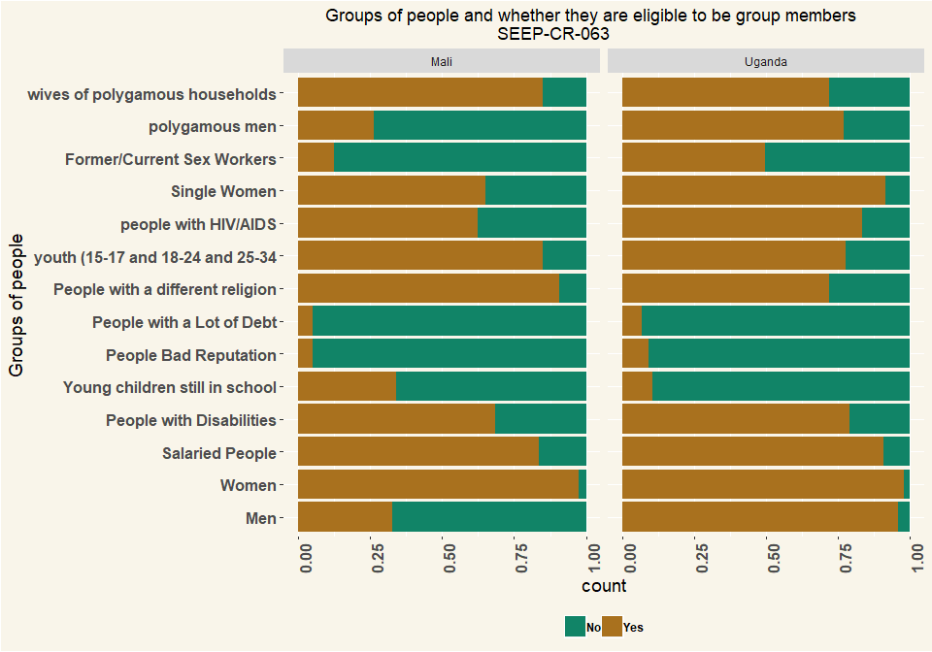

## # A tibble: 2 x 2  
## # Groups: Country [2]  
## Country n  
## <chr> <int>  
## 1 Mali 152  
## 2 Uganda 143

# 65 Does the VSLA group have any joint economic activity?

|  |  |  |
| --- | --- | --- |
| Activity | Mali | Uganda |
| Yes | 41 | 11 |
| No | 110 | 130 |
| I don’t know | 1 | 1 |
| Respondents | 152 | 142 |

# Q66 If so, please describe what these joint economic activities are?

|  |  |  |
| --- | --- | --- |
| variable | Mali | Uganda |
| Joint production | 33 | 6 |
| Bulk purchases of inputs | 5 | 1 |
| Bulk selling/Joint marketing of output | 6 | 1 |
| Group business | 1 | 5 |
| Other (specify) | 6 | 2 |
| Respondents | 51 | 15 |

# Q67. does the whole group do participate in {0} or only some of the members?

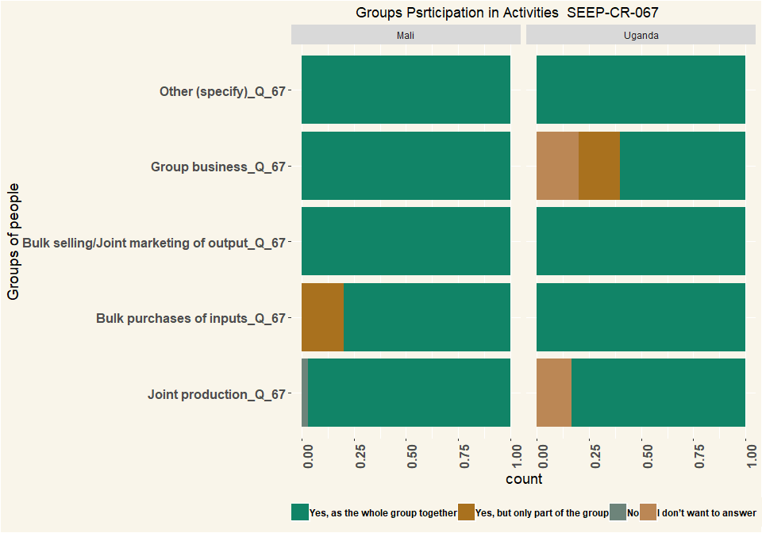

## # A tibble: 2 x 2  
## # Groups: Country [2]  
## Country n  
## <chr> <int>  
## 1 Mali 152  
## 2 Uganda 143

# Q68 Do the members trade with each other / provide each other business / refer customers to each other?

|  |  |  |
| --- | --- | --- |
| Trade | Mali | Uganda |
| Yes | 50 | 52 |
| No | 102 | 87 |
| I don’t know | NA | 3 |
| I don’t want to answer | NA | 1 |
| Respondents | 152 | 143 |

# Q69 Does your group have any relationship(s) with the following types of organisations?

|  |  |  |
| --- | --- | --- |
| variable | Mali | Uganda |
| NGOs | 3 | 26 |
| CBOs | 0 | 6 |
| Government agencies | 0 | 3 |
| Religious institutions (mosque, church, …) | 0 | 10 |
| Political party | 2 | 4 |
| Private company | 0 | 5 |
| Other (specify) | 0 | 0 |
| None | 147 | 100 |
| Does not want to answer | 0 | 2 |
| Respondents | 152 | 143 |

# Q72 How satisfied are you with this relationship with the organisation {0} ?

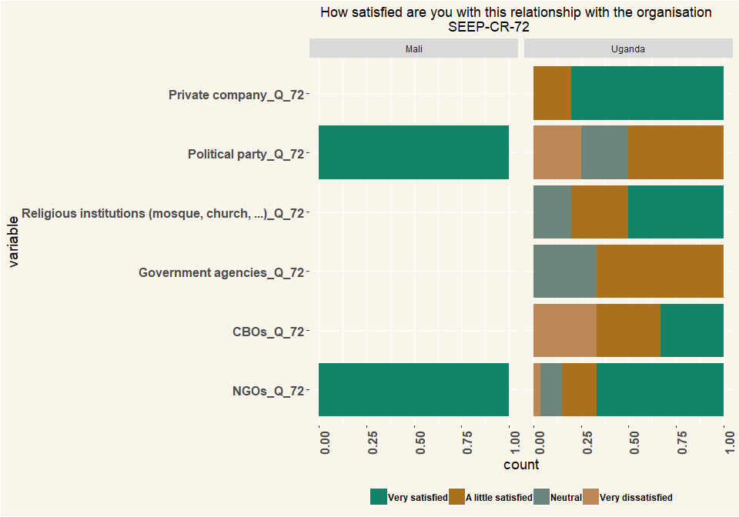

## # A tibble: 2 x 2  
## # Groups: Country [2]  
## Country n  
## <chr> <int>  
## 1 Mali 152  
## 2 Uganda 143

# Q73 Does the group have a relationship with a financial service provider?

|  |  |  |
| --- | --- | --- |
| Relation | Mali | Uganda |
| Yes, as a group | 6 | 25 |
| Yes, but individual members | 9 | 24 |
| No, nobody has any relationship | 135 | 74 |
| I don’t know | 2 | 20 |
| Respondents | 152 | 143 |

# Q74 What type(s) of relationship does the group have with a financial service provider?

|  |  |  |
| --- | --- | --- |
| variable | Mali | Uganda |
| Individual group members have accounts (unrelated to the group) | 10 | 34 |
| Individual group members have loans (unrelated to the group, group not guaranteeing loan) | 8 | 21 |
| Individual group members have accounts as a result of the group | 1 | 1 |
| Individual group members have loans, related to the group, group guaranteeing loan or member’s track record helping to get the loan | 0 | 3 |
| Group has an account (e.g. for excess funds) | 4 | 22 |
| Group has a loan from financial service provider | 0 | 6 |
| I don’t know | 1 | 1 |
| I don’t want to answer | 0 | 0 |
| Respondents | 24 | 88 |

# Q75 In what type of institution(s) does the group have an account?

|  |  |  |
| --- | --- | --- |
| variable | Mali | Uganda |
| Commercial Bank | 1 | 8 |
| MDIs | 0 | 0 |
| MFIs | 4 | 0 |
| Credit institutions | 0 | 0 |
| SACCOs | 0 | 2 |
| MNO (mobile money) | 0 | 0 |
| Other (specify) | 0 | 0 |
| I don’t want to answer | 0 | 0 |
| respondents | 5 | 10 |

# Q76 How did the group obtain its account?

|  |  |  |
| --- | --- | --- |
| Account | Mali | Uganda |
| Entirely group’s initiative/idea | 4 | 8 |
| Due to information from outside entity | NA | 1 |
| Suggested by outside entity | NA | 1 |
| respondents | 4 | 10 |

# Q80 Is the group registered with any local authority? E.g. with the municipality, ministry of cooperatives, chamber of commerce, etc.

|  |  |  |
| --- | --- | --- |
| Register | Mali | Uganda |
| Yes | 37 | 74 |
| No | 109 | 62 |
| I don’t know | 6 | 6 |
| I don’t want to answer | NA | 1 |
| Respondents | 152 | 143 |

# Q81 Why is the group registered?

|  |  |  |
| --- | --- | --- |
| Register | Mali | Uganda |
| It is an obligation from the government | 1 | 24 |
| We wanted to formalize our group / we wanted to register | 22 | 45 |
| We needed the registration for getting a bank account | 3 | 1 |
| We needed the registration for something else | 11 | 1 |
| Other (specify) | NA | 3 |
| Respondents | 37 | 74 |

# Q82 At which office did you register the group?

|  |  |  |
| --- | --- | --- |
| Office | Mali | Uganda |
| Department/Ministry of cooperatives | 1 | 14 |
| Townhall | 36 | 6 |
| Mosque/church | NA | 3 |
| District | NA | 5 |
| Local council | NA | 1 |
| Sub-County | NA | 32 |
| Village level | NA | 1 |
| respondents | 37 | 62 |

# Q83 Did it cost any money to register?

|  |  |  |
| --- | --- | --- |
| Cost | Mali | Uganda |
| Yes | 31 | 69 |
| no | 6 | 4 |
| I don’t know | NA | 2 |
| Respondents | 37 | 75 |

# Q84 How much did the registration cost?

* UGX/Dollar = 0.00027
* Mali CFA Franc (XOF)/Dollar = 0.0017

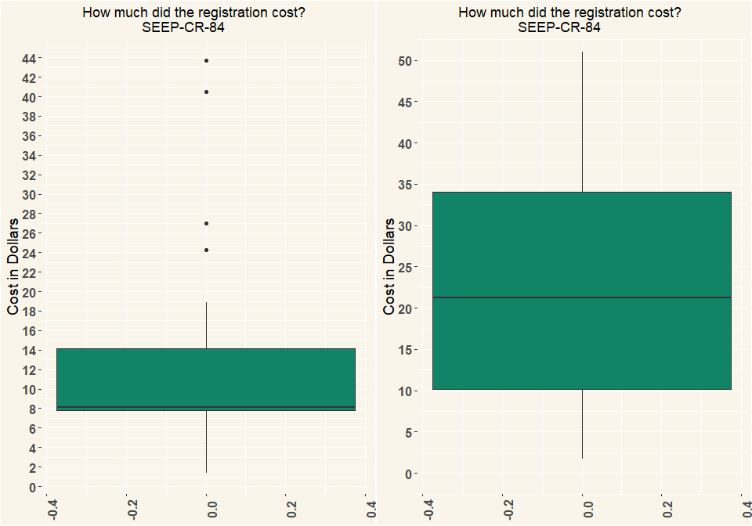

## # A tibble: 2 x 2  
## # Groups: Country [2]  
## Country n  
## <chr> <int>  
## 1 Mali 17  
## 2 Uganda 64

# Q85 What are the benefits of registration? (Multiple Selection)

|  |  |  |
| --- | --- | --- |
| variable | Mali | Uganda |
| Members take the group more seriously | 29 | 66 |
| Outsiders take the group more seriously | 35 | 51 |
| We can access support | 30 | 38 |
| We can open a bank-account | 12 | 20 |
| Other (specify) | 0 | 1 |
| Respondents | 152 | 143 |

# Q86 Does the group use any form of technology? E.g. calculator on phone? an app on a phone to do bookkeeping?

|  |  |  |
| --- | --- | --- |
| Technology | Mali | Uganda |
| Yes | 25 | 130 |
| No | 127 | 13 |
| respondents | 152 | 143 |

# Q87 What forms of technology does the group use?

|  |  |  |
| --- | --- | --- |
| variable | Mali | Uganda |
| Stand-alone calculator | 22 | 59 |
| Calculator on simple phone | 19 | 111 |
| Calculator on smart phone | 16 | 8 |
| Sending messages on simple phone | 0 | 9 |
| Sending messages on smart phone | 0 | 1 |
| Recording numbers or balances on simple phone | 0 | 2 |
| Recording numbers or balances on smart phone | 0 | 0 |
| Camera on simply phone | 0 | 13 |
| Camera on smart phone | 0 | 4 |
| Other | 1 | 1 |
| respondents | 22 | 95 |

# Q91 What is the gender of the respondent?

|  |  |  |
| --- | --- | --- |
| Gender | Mali | Uganda |
| Female | 152 | 90 |
| Male | NA | 53 |
| Respondents | 152 | 143 |

# Q92 Could you estimate the age of the respondent?

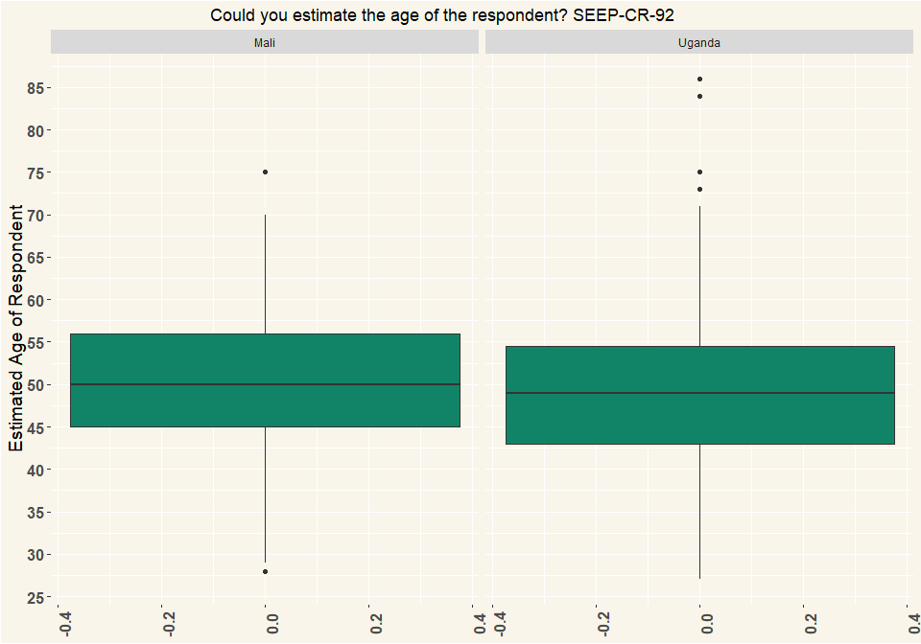

## # A tibble: 2 x 2  
## # Groups: Country [2]  
## Country n  
## <chr> <int>  
## 1 Mali 152  
## 2 Uganda 135